# Open this link for APK

<https://drive.google.com/file/d/1eIzHvXLXLcrC_ZDb2kBKqvZfTQzzPv3t/view?usp=sharing>

# Open this link for database

<https://pashto-quran-app-demo.firebaseio.com/Surahs/1/Ayats/1>

login through the email you gave me

(you cannot access untill I don’t add your email as a collaborator send me your email for this and note it should be a gmail account)

webpage will look like this

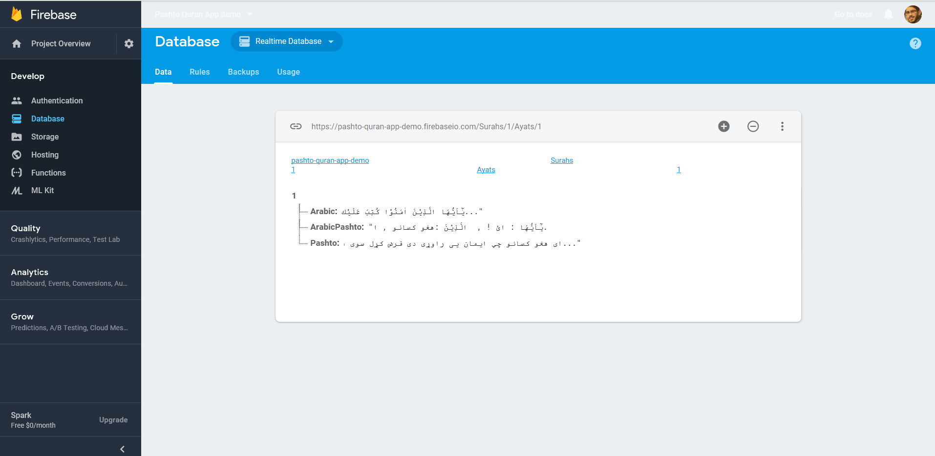

# To edit Arabic content

Don’t change key word “Arabic” just change the content when you change the text and want to save press enter (due to some reasons it saves the data when enter is pressed)

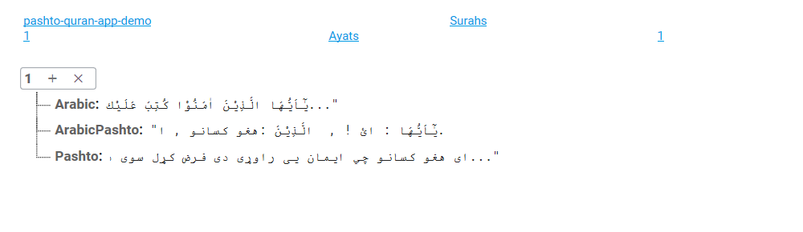

# To edit Pashto content

Don’t change key word “Pashto” just change the content and want to save press enter (due to some reasons it saves the data when enter is pressed)



# To edit Pashto content

Don’t change key word “ArabicPashto” just change the content and want to save press enter (due to some reasons it saves the data when enter is pressed). Kindly read note before editing this field

Note:

Your text should be in proper format i.e insert comma after every word (Arabic + translation) like I changed the field you gave in (I inserted comma in this paragraph)

يٰٓاَيُّهَا : ائ ! , الَّذِيْنَ : هغو کسانو , اٰمَنُوْا : چي ایمان يي راوړی دی , كُتِبَ : فرض کړل سوی ده , عَلَيْكُمُ : پرتاسو باندی , الصِّيَامُ : روژه , كَمَا : لکه څنګه چي ,كُتِبَ : فرض کړل سوی وه , عَلَي : پر , الَّذِيْنَ : هغو کسانو , مِنْ : چي , قَبْلِكُمْ : دمخه ستاسو څخه وه , لَعَلَّكُمْ : دپاره ددې چي تاسي , تَتَّقُوْنَ : ځان وساتئ



Some other Notes

Please **Change the Content Only**

Please Follow the format for ArabicPashto

Currently this app may not work on all devices but it will work on nougat and oreo

Final App will work on all devices higher than 4.0.0

Currently this works on one ayat only

Kindly don’t play with database

Thanks ☺